The Legacy of G. A. Cohen: Ten Years On

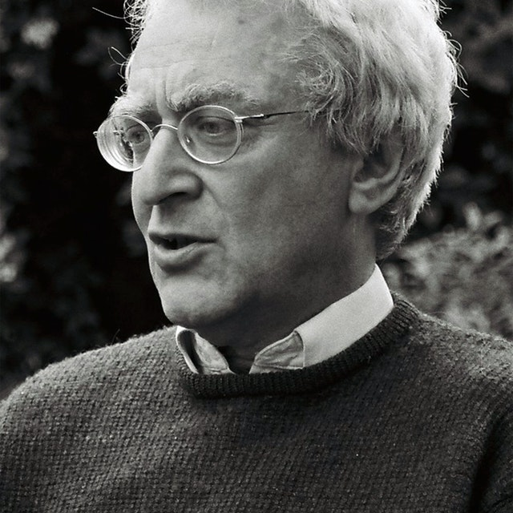

Convenors: Igor Shoikhedbrod & Shlomi Segall

Tuesday, December 10th

8:45 Opening Remarks from Halbert Centre for Canadian Studies

9:00- 10:00
Christine Sypnowich, Queen’s University, “’No-Bullshit Marxism’, or If Jerry Cohen was an egalitarian, how come he was an analytical philosopher?"
Chair commentator: Dani Attas, The Hebrew University
10:00-11:00
Igor Shoikhedbrod, University of Toronto, "Market Socialism and the Normative Relevance of Adaptive Preference Formation”
Chair commentator: Ori Lev, Sapir College
11:30-12:30
Avigail Ferdman, National Economic Council, “Pluralism and Conservatism in Public Space: Towards Human Flourishing in the Commons”
Chair commentator: Tal Alster, The Hebrew University
Lunch: 12:30-14:00

14:00-15:00
Re’em Segev & Ofer Malcai, The Hebrew University, ‘A Dilemma for Luck Egalitarians’
Chair commentator: Natan Milikowsky, The Hebrew University

15:00-16:00
Kristin Voigt, McGill, “Regarding Oneself as an Equal” (a paper co-authored with Natalie Stoljar)
Chair commentator: Avner de Shalit, The Hebrew University

Coffee break

16:30-17:30,
Colin Macleod, University of Victoria, “Diagnosing the ‘Burdens’ of the Rich Egalitarian: How Capitalism Nurtures Pleonexia"
Chair commentator: David Heyd, The Hebrew University

Workshop Dinner

Day 2 Wednesday, December 11, 2019

8:45-9:45
Daniel Statman, University of Haifa, “The Ethics of Blaming”
Chair commentator: Daniel Schwartz, The Hebrew University

9:45-10:45
Daniel Weinstock, McGill, “How Paradoxical are the ‘Paradoxes of Conviction?”
Chair commentator: David Enoch, The Hebrew University

10:45-11:15 Coffee Break

11:15-12:15,
Saul Smilanksy, University of Haifa, “Can an Egalitarian Complain”?
Chair commentator: Shlomit Wygoda-Cohen, The Hebrew University

12:15-13:00
Hillel Steiner, Manchester, ‘Where the Action Was: Personal Reflections on Jerry’
Chair: Adina Preda, Trinity College Dublin

